**Guide to PharmOutcomes**

**for the**

**Change Grow Live Core MAT Service**

**v1.0 January 2023**

**Welcome to the PharmOutcomes guide for the Change Grow Live core MAT service.**

Accurate and complete data collection and recording relating to the core MAT service is vital to ensure the entire healthcare team looking after the individual has access to the same up-to-date information.

Interoperability of PharmOutcomes with Change Grow Live systems means that information recorded by community pharmacies providing the MAT core offer will integrate directly into the service user clinical record. This will drive the quality of care and treatment provided and enable us to identify and action more targeted support which the individual person needs as part of their treatment and recovery journey.

By utilising PharmOutcomes for data collection and communication between Change Grow Live services and pharmacies, this streamlines the way we work together and helps us to do things better.

Please use this guide to help you with capturing the important information we need to best support the people who use our services.

**Registration for all CGL MAT clients**

**Please ensure you are enrolled as a practitioner before entering any data.**

1. Enter the name or registration number of the practitioner providing the service and select the correct option from the list.
   1. If practitioner registration is required, select the “new practitioner” option and complete the required steps.

1. The registration date box will auto-populate with today’s date. An alternative date can be selected using the dropdown calendar if needed.

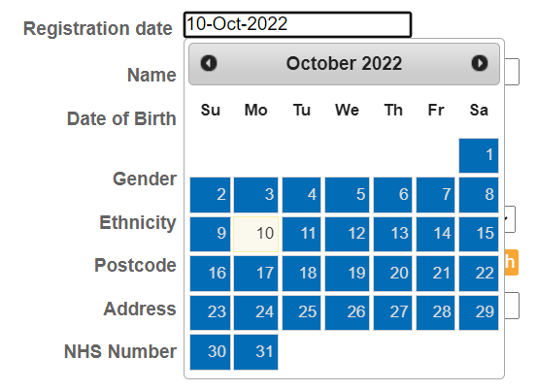

1. Search for the person via the Personal Demographic Service (PDS) by entering either the requested personal details, or their date of birth and NHS number:

1. Once the persons details are entered, click the “Lookup via PDS” button. The persons details will be populated. Confirm the correct person has been identified by clicking “Confirm patient”.

1. Where known, record the name of the service users keyworker so a named contact is identified.

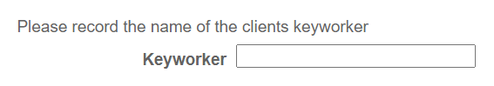

1. Save the completed entry to complete the registration process.

**CGL MAT – Missed or late collection**

**Please ensure you are enrolled as a practitioner and the service user has been registered on PharmOutcomes before entering any data.**

This is to be completed for all people receiving MAT treatment who collect a dose late or miss a dose. This information must be recorded accurately on PharmOutcomes:

* to allow the prescribing service to intervene and provide support to the individual at critical times in their treatment and recovery.
* to ensure we have up-to-date information about the persons adherence to their medication which helps to inform their treatment plan and improve the care we provide.
* within 1 working day of the late or missed dose

Please note: the need to report activity relating to individual supervised doses for each day has been removed.

When 3 doses have been missed, no further doses should be dispensed. The prescribing service should be contacted for medication to be restarted.

1. Enter the name or registration number of the practitioner providing the service and select the correct option from the list.
   1. If practitioner registration is required, select the “new practitioner” option and complete the required steps.

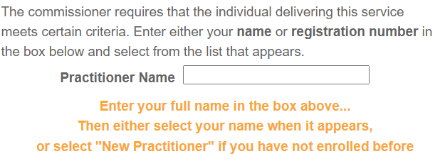

1. The reporting date box will auto-populate with today’s date. An alternative date can be selected using the dropdown calendar if needed.

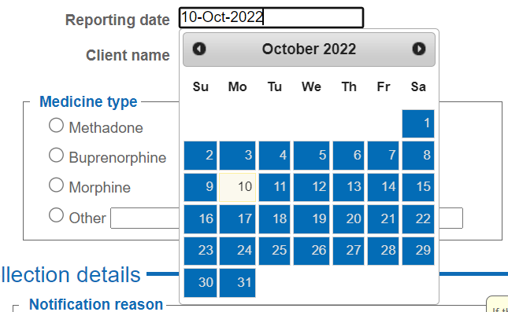

1. Search for the service user’s name and select the correct name and date of birth from the options listed.

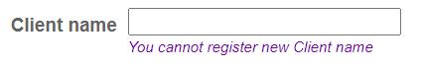

1. Select the name of the medication on the prescription in the “Medicines type” box.
   1. For methadone or buprenorphine, select the correct formulation from the sub-menu options.

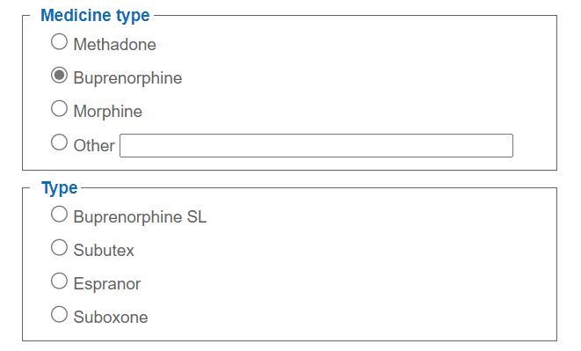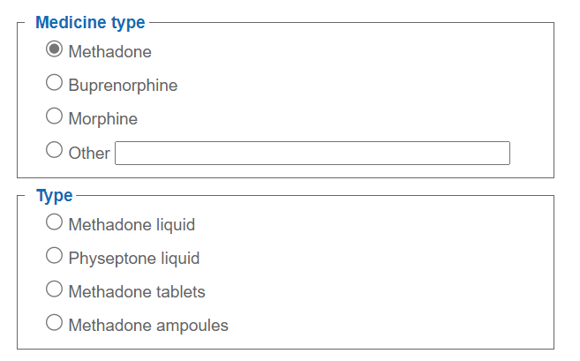

* 1. For “other” medication, enter details of the medication name and formulation into the box.

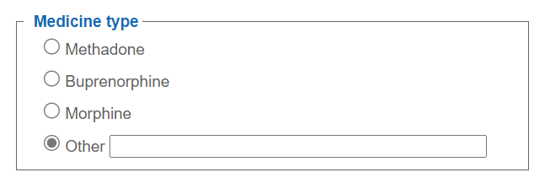

1. Select whether the collection instance you are reporting is a missed dose, or was collected on a date later than that intended.
2. For a missed collection, click the “date of missed collection” box and select the date when the dose was missed on the dropdown calendar.

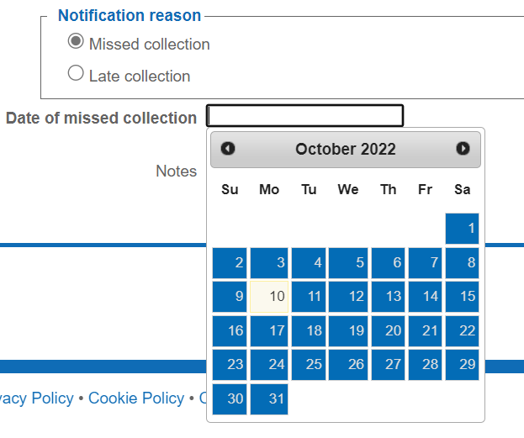

1. For a late collection, click the “date of late collection” box and select the date when the late dose was collected on the dropdown calendar.

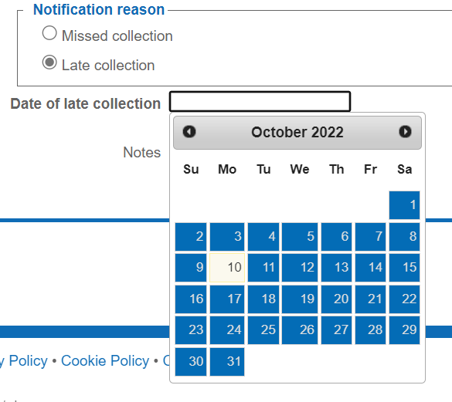

1. Please make any relevant notes in the box provided, for example if a reason was provided for the late or missed dose, or if there are any observed patterns relating to dose collection. Any concerns relating to safeguarding should be reported to the prescribing service immediately.

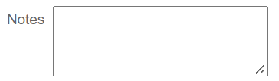

1. Save the completed entry to complete the missed or late dose record.

**CGL monthly supervised/unsupervised dispensing**

**Please ensure you are enrolled as a practitioner and the service user has been registered on PharmOutcomes before entering any data.**

This service should be completed once dispensing for the month has finished.

1. Enter the name or registration number of the practitioner providing the service and select the correct option from the list.
   1. If practitioner registration is required, select the “new practitioner” option and complete the required steps.

1. The provision date box will auto-populate with today’s date. An alternative date can be selected using the dropdown calendar if needed.

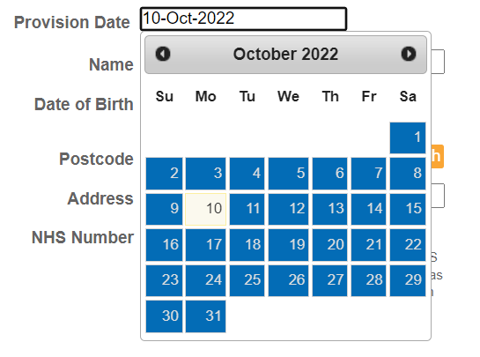

1. Search for the person via the Personal Demographic Service (PDS) by entering either the requested personal details, or their date of birth and NHS number:

1. Select the name of the medication on the prescription in the “Medicines type” box.
   1. For methadone or buprenorphine, select the correct formulation from the sub-menu options.

* 1. For “other” medication, enter details of the medication name and formulation into the box.

1. Select the month of dispensing and/or supervised consumption to which the record relates using the dropdown menu:

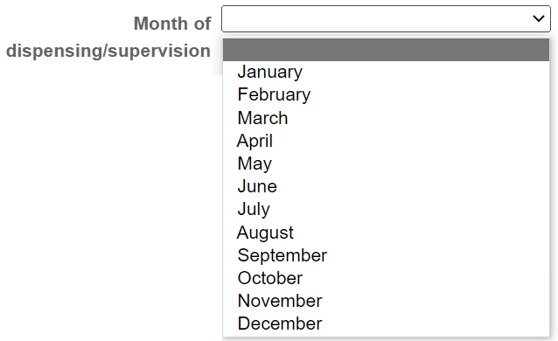

1. Select whether supervised consumption has been provided or not at any time during the month:



* 1. If supervised consumption has been provided, enter the number of doses which have been supervised this month. (Note: each instance of supervised consumption attracts an activity fee)

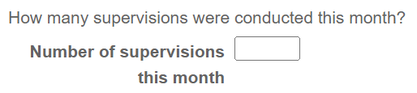

1. Confirm that all missed doses or late collections have been reported using the “CGL MAT – Missed or late collection” service on PharmOutcomes.

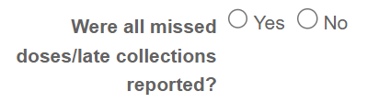

* 1. If ‘No’ is selected, a message will be displayed to remind you to ensure all missed doses and late collections are reported using the “CGL MAT – Missed or late collection” service on PharmOutcomes.

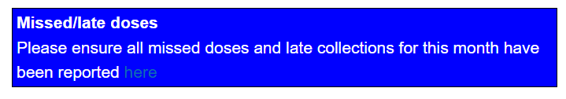

1. Select the correct option to record whether 10 or more days medication has been dispensed to this service user this month. (Note: all instances of dispensing medication to cover at least 10 days attracts an activity fee)

1. Save the completed entry to complete the monthly dispensing record.

**MAT quarterly review**

**Please ensure you are enrolled as a practitioner and the service user has been registered on PharmOutcomes before entering any data.**

1. Enter the name or registration number of the practitioner providing the service and select the correct option from the list.
   1. If practitioner registration is required, select the “new practitioner” option and complete the required steps.

1. The provision date box will auto-populate with today’s date. An alternative date can be selected using the dropdown calendar if needed.

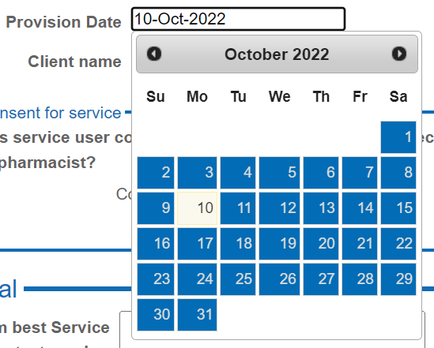

1. Search for the service user’s name and select the correct name and date of birth from the options listed.

1. Ask the service user for consent to conduct the MAT quarterly review. Record whether consent is given or not given.

* 1. If consent is not given, end the review process and complete the service to record that a MAT quarterly review was attempted.

1. If consent is given to conduct the review, then gain consent to share data for the information obtained during the MAT quarterly review to be passed to CGL. Record whether consent is given or not.

1. If consent is given to share data with CGL, proceed with the MAT quarterly review.
2. If consent is not given, end the review process and complete the service to record that a MAT quarterly review was attempted.

Conducting the MAT quarterly review

1. Check with the service user their preferred contact telephone number and record in the box provided.

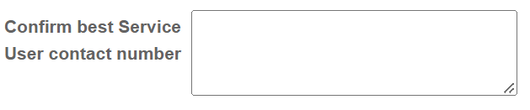

1. Ask the service user if they are aware of when their next appointment is with the prescribing service and select the correct answer.

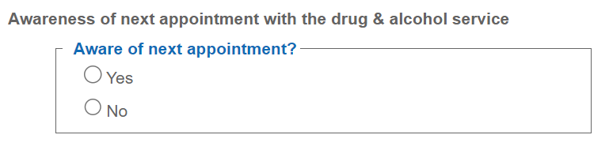

1. Talk to the service user about the importance of adherence to their prescribed medication and any potential barriers or issues they are facing. Ensure they are aware of how to take the medication they are prescribed. Record notes of this discussion in the note box.

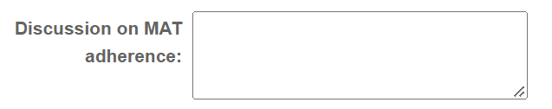

1. Using feedback from the service user and your professional opinion, select if there is anything we can do to help the person with their treatment adherence, and if so, provide details in the note box.

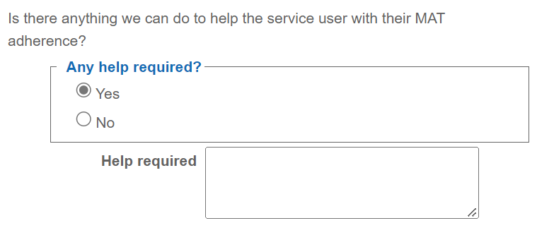

1. Where the MAT dose is not within Orange Guideline recommendations (60-120mg methadone or 12-16mg buprenorphine) explore and discuss reasons and barriers as to why this may be. Record notes of the discussion in the note box.

1. Using feedback from the service user and your professional opinion, select if there is anything we can do to help the person with optimising their MAT dose, and if so, provide details in the note box.

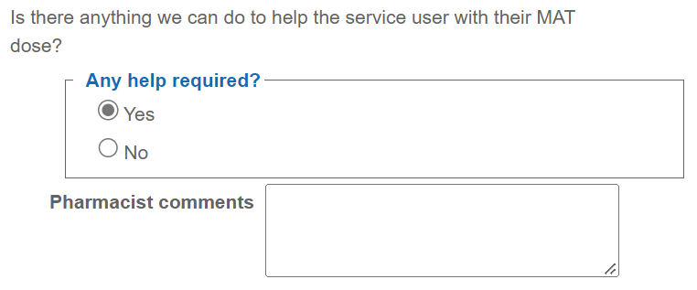

1. Check if the service user has a naloxone kit which is in date, and that they know how to use it.
2. If they require a kit, select “yes” and either train and supply in the pharmacy, or refer to their treatment service. Select the appropriate option.
3. If a kit is not required, select “no”.

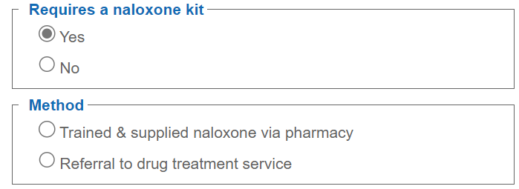

1. Where appropriate, discuss lifestyle factors such as smoking status, alcohol consumption, and diet. Select whether a discussion has taken place.
2. If required, offer pharmacy services or signpost to services which can support the person with their lifestyle. Select the correct option and add any relevant comments.
3. If not required, select “none of the above” and add any relevant comments.

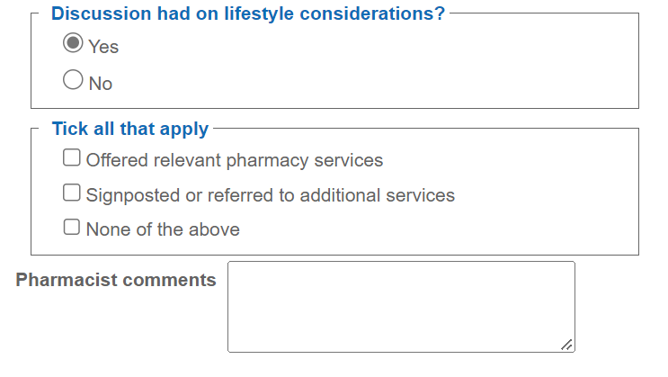

1. Give the person the opportunity to discuss anything else.
2. If they wish to discuss anything, select “yes”, and record any relevant notes or actions.
3. If there is nothing further to discuss, select “no”.

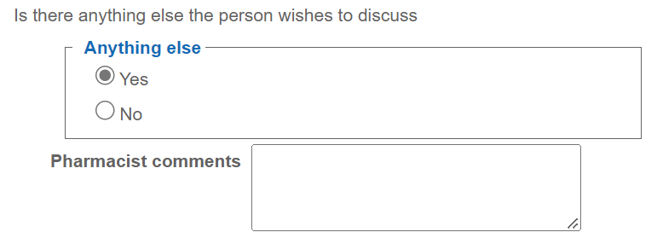

1. Save the completed entry to complete the MAT quarterly review record.
2. Record completion of the MAT quarterly review on the service users PMR.