East of England Teach and Treat project – FAQs for community pharmacists

What is the Teach and Treat project?
NHS England have provided funding to the Integrated Care Systems (ICSs) in the East of England to pilot a ‘Teach & Treat’ project. The aim is to provide community pharmacists with the opportunity to train as Independent Prescribers (IPs) and ultimately provide a future pipeline of IP supervision.
Within the East of England we are currently piloting a Teach & Treat project, which involves a hub-and-spoke model, with one centralised (regional) Teach and Treat hub, and a small number of Designated Prescribing Practitioner (DPP) “spokes” across the region. The central hub provides coordination for the project, IP trainee & DPP support, and delivers additional learning opportunities for IP trainees to complement the university prescribing course. NHS England have now extended our funding for a second year, enabling twelve DPP spokes to be set up across the East of England, supporting up to 24 community pharmacists to train as IPs. We plan to have two DPP spokes within Suffolk and North East Essex (SNEE) ICS and two spokes within Norfolk and Waveney (NW) ICS supporting four community pharmacists in each area.
Why should I apply?
If you want to train as an IP, this is an opportunity to take part in a project that will provide you with a DPP plus additional, quality assured, IP training & support – at no additional cost to yourself.
Am I eligible to apply?
The eligibility criteria are:
- Intention to Enrol: You must be able to start a GPhC-accredited IP training programme in March 2026 using the UEA
- Area of practice: You must work as a community pharmacist within the SNEE or NW areas for at least three days per week
- Employer Support: Your employer must provide necessary support for your training, including appropriate cover during your absence (no backfill costs will be covered)
You would also need to agree to becoming a future DPP after completion of your IP course (and subsequent consolidation of prescribing practice).
What will each DPP spoke do?
Each DPP spoke will provide DPP supervision for two community pharmacists for the duration of their prescribing course.
Where will the spokes be located?
There will be two DPP spokes within Suffolk and North East Essex; details/locations are yet to be confirmed. Similarly there will be two spokes within Norfolk & Waveney. Allocation of successful applicants to a DPP spoke will be guided by the applicant’s preferred scope of practice, and their geographical proximity to the available spokes (where possible).
What will the central hub do?
We will provide a total of 24 hours of learning in practice (delivered by University of East Anglia [UEA]), which can be counted towards the 90 hours required by each IP trainee. This learning will cover:
- Management and communication of clinical information
- Consultation Skills
- Physical assessment of patients
Please note, this would require you to attend three face-to-face study days, which we will aim to be in a central location within the East of England (venue & dates TBC). These are likely to run on Sundays (to facilitate attendance).
We will also set up a ‘community of practice’ for pharmacists taking part in this project, which will provide an opportunity to link with others in the region. In addition, we are keen to support our Teach & Treat pharmacists to confidently prescribe in new therapeutic areas (once qualified), so are working on plans for ongoing support/supervision.
What scopes of practice could I chose from?
We have worked with University of East Anglia to produce three potential scopes of practice:
- Primary hypertension
- Menopause
NB – DPP spokes will be given the opportunity to select which of the above scopes they would like to deliver, therefore the choice may be limited. As part of the application process you will be asked to rank your preferences.
Which university would I attend, & what are the IP course learning requirements?
We plan to work with University of East Anglia (UEA) to deliver this project, so if you are successful, you’ll need to be willing to attend their IP course. Further details for the UEA IP course are available at: https://www.uea.ac.uk/course/postgraduate/credpg-independent-prescribing-for-pharmacists-credit-only-uea-part-time#course_modules.
Please note that UEA require compulsory attendance at TEN study days. Whilst the majority of these are online, there are two face-to-face study days which support you with physical assessment and examination skills. Please note you will not be accepted onto the UEA IP course unless you can attend all compulsory sessions:
- Thurs 26th March - Introduction to the course
- Wed 29th April OR Thurs 30th April - Study day 2 (Face to Face)
- Thurs 14th May - Study day 3
- Thurs 21nd May - Study day 4
- Thurs 4th June - Study day 5
- Wed 10th June OR Thurs 11th June - Simulated Patient Assessment
- Thurs 25th June - Study day 6
- Thurs 2nd July - Study day 7 contd…
- Wed 15th July OR Thurs 16th July - Study day 8 (Face to Face)
- Wed 16th September OR Thurs 17th September - Case Based Discussions
All IP courses usually last 6 months, and necessitate a minimum of 26 days of formal teaching and learning activities. Additionally, you will be required to complete at least 9 days (66 hours) of supervised practice-based learning under the guidance of a DPP.
What is the deadline for UEA applications?
Successful applicants will need to submit their IP application to UEA by 19th January 2026.
Will you provide help to prepare my UEA application?
Yes, UEA will provide a 1-hour webinar to support successful Teach & Treat pharmacists to prepare their IP application. The provisional date for this session is Friday 9th January 2026, with a session at lunchtime, repeated in the evening.
Who funds the university IP courses?
NHS England fund IP courses for community pharmacists. For more information, including details of the course at UEA, see: LINK.
You do not need to apply for this funding separately, it will be managed by the UEA.
Is there anything else I need to pay for?
You will not need to pay to be part of the Teach & Treat project; your DPP and central hub support/teaching will be provided without a cost to yourself.
Please note, we are not able to cover backfill costs, so you will need your employer’s support before applying. We are also unable to reimburse travel costs.
If selected, what will be expected in return?
As this is a pilot project, we need to collect information to evaluate the outcomes. You will therefore be asked to particate in an evaluation to share your thoughts & experiences. This may take the form of questionnaires or short online interviews/focus groups.
How can I apply?
If interested, please complete the relevant area online expression of interest (EOI) form by midnight on Sunday 21st December 2025:

Link to SNEE EOI form: SNEE ICB Community Pharmacists: Expression of Interest for Teach & Treat Project – Fill out form or use the QR code:
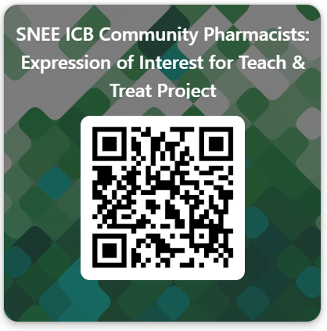

Link to NW EOI form: N&W Community Pharmacists: Expression of Interest for Teach & Treat Project – Fill in form or use the QR code:
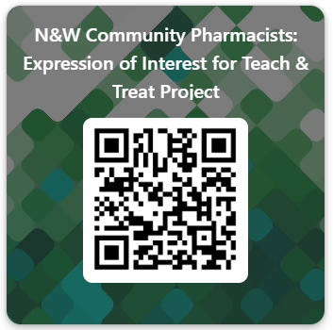

How will you decide who is successful?
We will apply scoring criteria to determine who is successful. Please note that we are keen to address the needs of communities who are underserved or marginalised, therefore would like to prioritise pharmacists working within deprived and/or rural communities for inclusion into the Teach & Treat project where possible.
We are aiming to shortlist as soon as possible after the EOI closes; you should be informed of the outcome on/before Tuesday 6th January 2026.
Who can I contact for more information?
Suffolk & North East Essex: Ben Leung – Deputy Chair of SNEE ICS Pharmacy Workforce Group, SNEE ICB:
ben.leung@snee.nhs.uk
Norfolk & Waveney: Helen Palmer – Head of Pharmacy Workforce, NW ICB: helen.palmer37@nhs.net

Originally prepared by Cathy Geeson, Teach & Treat Project Manager, 01 December 2025

