Online workshops – now live for booking!

Dates for online workshops running from January-March 2026 go live on 3rd November 2025. Book an event.

Reminder about upcoming face to face workshops in the region.

- Weight Management: prescribing perspectives.

This workshop will support you in developing long lasting peer support networks as you expand your scope of practice in medicines supply. It is open to pharmacy professionals across all sectors. The aim of the programme is to develop knowledge and skills to adopt a structured approach to safely supply weight management medicines, whether through prescribing or under a patient group direction (PGD).
Dates and locations for workshops taking place in the region:

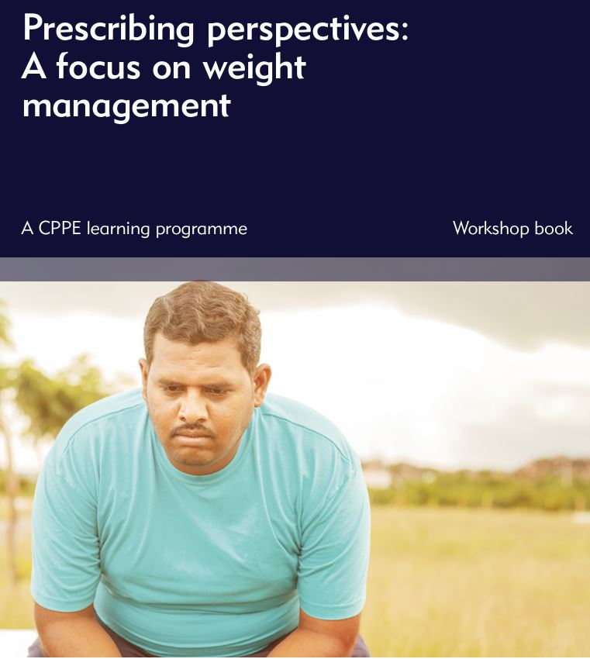
4 November 2025 – Hertfordshire Sports Village, Hatfield
12 November 2025– University of East Anglia, Norwich
13 January 2026 – Anglia Ruskin University, Chelmsford
10 February 2026 – Cranfield University
12 March 2026 - Hertfordshire Sports Village, Hatfield
17 March 2026 - Anglia Ruskin University, Chelmsford
18 March 2026 – Brampton Park Golf Club, Huntingdon

Book a workshop

- Blood pressure assessment in community pharmacy: essential skills workshop

The aim of this programme is to enable pharmacy professionals to build the
knowledge, skills and confidence to deliver person-centred consultations
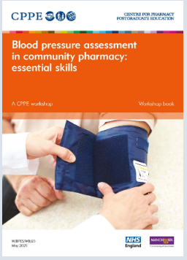
and clinical assessments as part of the NHS Hypertension Case-Finding
Service (HCFS). It includes practical skills training supported by a clinical
demonstrator.
21 January 2026 – Hertfordshire Sports Village, Hatfield
Book a workshop:
Blood pressure assessment in community pharmacy: essential skills : CPPE

Keep up to date with CPPE news

Check our My CPPE profile to ensure you have selected your preferences to receive news from CPPE via email. You can also check out the latest news by going to the CPPE homepage and clicking the latest news link under the “About CPPE” tab at the top of the homepage.

Supporting Community Pharmacy England 2025/26 contract changes from 29 October 2025

We have updated our NHS Pharmacy Contraception Service (PCS) : CPPE landing page to include:
- Addition of oral emergency contraception to the service.
- Ability of pharmacy technicians to provide the service
- Addition of drospirenone within the list of contraceptives which can be supplied.
We have updated our NMS : CPPE landing page to reflect the addition of antidepressants along with some resources that we expect pharmacy professionals will find useful as they start to deliver this service.

What’s New at CPPE?

Autism and ADHD: Supporting inclusive person-centred care e-learning programme

This programme explores the lived experiences of autistic people and people with ADHD, helping you adapt your consultation style and approach.

Digital healthcare learning gateway

We have a new learning gateway on digital technology and clinical informatics, supporting pharmacy professionals with the knowledge and confidence to thrive in a digitally enabled NHS. The learning gateway aligns with the Health and Care Digital Capabilities Framework and helps learners explore how digital systems and informatics shape everyday pharmacy practice.

Supporting people living with Long Covid


Pharmacy teams are often the first point of contact for people living with
Long Covid, making community pharmacy a vital place for support.
To meet this need, CPPE has developed Supporting people living with
Long Covid in collaboration with a consortium of universities.
This new learning programme is informed by lived experience and
backed by research being carried out by the NIHR-funded PHARM-LC study.

Fundamentals of structured medication review (SMR) e-course

Previously tutor-led, we have redesigned the programme into an interactive, flexible, self-directed e-course. It supports pharmacists, pharmacy technicians and trainee pharmacists to develop the right knowledge, skills and behaviours to undertake person-centred SMRs, or contribute to related activities within their organisations.

Press release- Atrial fibrillation

Download this press release as a PDF, introducing Optimise Atrial fibrillation: Focus on direct-acting oral anticoagulants. This programme is a one-hour, peer learning session helping pharmacy teams build confidence, share strategies and refine clinical decision-making to support people in making informed choices about their anticoagulation therapy.

Press release- New webinar series to highlight pharmacy technicians’ diverse roles

You can read a PDF version of this press release here.and details of webinar sessions and speakers.

CPPE Pharmacy conversations – new topic on Menopause and pharmacy practice

In this episode, we explore the vital topic of menopause and its impact on women’s health, with help from our guests Sally Arnison and Afua Thompson. Together, they share personal insights, professional experiences, and practical tips for pharmacy teams to better support people going through perimenopause and menopause. Tune in to hear about recognising symptoms, starting conversations, signposting to services and tackling barriers to care. We also consider training opportunities, policy change and how you can normalise discussing this sometimes-sensitive topic.

Inclusive pharmacy practice (IPP) week 24-27 November 2025

We are delighted to be supporting Inclusive Pharmacy Practice (IPP) week, which is a new joint initiative between 16 national pharmacy partners. It's about creating inclusive workplaces and leadership that reflects diverse communities, supporting efforts to reduce health inequalities.

IPP week 2025 consists of eight virtual interactive workshops grouped under three themes:
- Leadership and representation
- Healthcare service delivery
- Education and training
Each workshop is hosted by two IPP partner organisations and features senior leaders from within these organisations, alongside invited speakers delivering practical workshops and learning opportunities.
For full event descriptions, please see our Full programme booklet.
Clinical Pharmacy Congress North (CPC North) – 21-22 November 2025, Manchester

CPC North brings together over 1500 pharmacy professionals for two days of education, networking and innovation tailored to the North of England. CPPE is a lead educational partner for CPC North. Registration is completely free for pharmacy professionals, so sign up now.

World Antimicrobial Resistance Awareness Week 18- 25 November 2025
European Antibiotic Awareness Day 18 November 2025

Take a look at our learning gateway page in support of raising awareness around antimicrobial resistance. Explore your role in promoting antimicrobial stewardship and reducing antibiotic resistance by following Gwendolen’s story. Make antimicrobial stewardship a routine part of your practice and pledge or renew your pledge to become an Antibiotic Guardian.

CPPE Leading for change programme

Applications are open for the next cohort 7, from 3 November 2025 with cohort 7 starting in January 2026.

CPPE Extended programmes

- Pharmacy technician development programme: preparing for the future.
CPPE has launched a new programme for pharmacy technicians working across all sectors. This blended learning programme combines flexible online learning, interactive online and face-to-face workshops, and guidance from a dedicated education supervisor. From the outset, participants complete a learning needs review to tailor their personal development plan and prioritise learning most relevant to their practice.
The programme is designed to help pharmacy technicians build confidence in clinical, leadership and decision-making skills, with a strong emphasis on adapting to the expanding scope of pharmacy technician practice. This includes supplying and administering medicines under a PGD, such as the October 2025 expansion of the Pharmacy Contraception Service, and evolving requirements under the NHS Pharmacy First scheme. It will also be adapted to include learning on the pending supervision legislation changes.

Celebrating diversity

Every month, we publish an article on the CPPE news page of our website, celebrating diversity and highlighting how forthcoming celebrations, festivals or observances can impact on pharmacy practice. The November 2025 cultural and identity-linked celebrations, observances and awareness days include Movember, All Saints Day and Sri Guru Nanak Dev Ji Gurpurab.

Read the November article.

