Online and face to workshops

Dates for online and face to face workshops for our spring / summer semester have now gone live on the CPPE website. We have a brand new topic on the subject of the Menopause and two full day events in the region focusing on developing Respiratory clinical assessment skills and NHS Pharmacy First clinical assessment and examination skills.

Menopause: prescribing perspectives programme

Pharmacies are increasingly the first point of contact for people seeking support with menopause symptoms. Our new Menopause prescribing perspectives programme is designed to help pharmacists, pharmacy technicians and trainee pharmacists develop a structured, safe and person-centred approach to consultations and medicines supply where indicated. The programme arrives at a pivotal time for the profession, as more pharmacists qualify as independent prescribers from 2026 and an increasing number begin to use their prescribing skills.
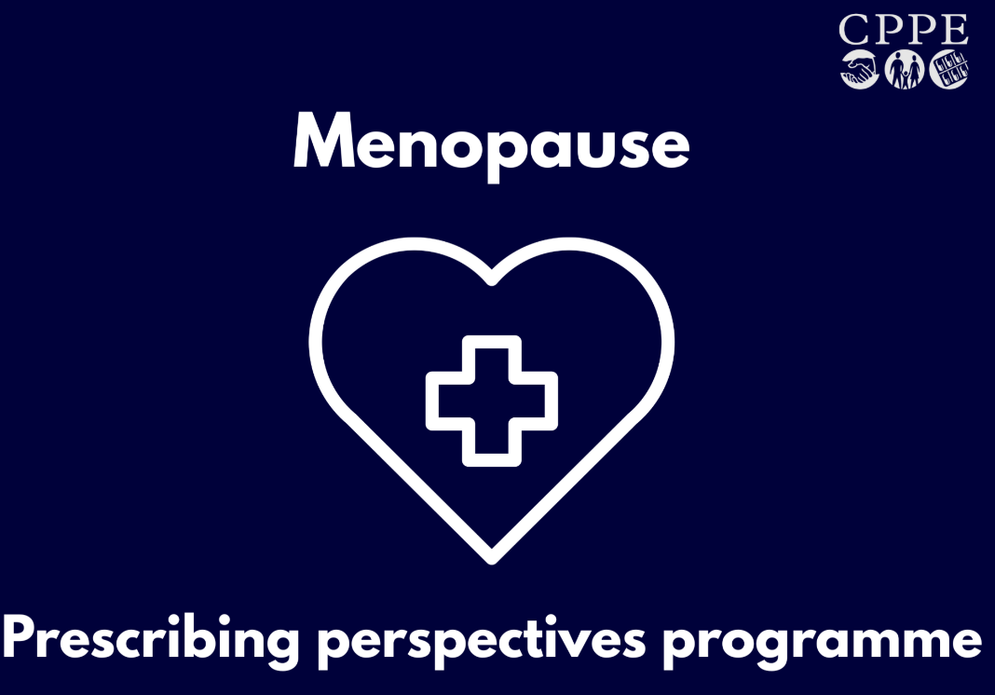

Face to face workshops will be run in the following locations in the region:

28 April – Hatfield
7 June - Colchester
23 June – Norwich
28 June – Cambridgeshire
17 September - Chelmsford
22 September – Flitwick, Bedfordshire
28 September – Diss, Norfolk

Optimising inhaler technique: improving outcomes

We are delighted to have collaborated with the pharmacy team at Addenbrooke’s hospital, using funding from NHS England to support pharmacy technician development, to run an inhaler training event. This event will be hosted at the Deakin Centre at Addenbrooke’s hospital on 30th March from 5:30 – 7:30pm and places are available for booking now for all pharmacy professionals, including pharmacy technicians, pharmacists and trainee pharmacists across all pharmacy sectors.

Booking link - https://www.cppe.ac.uk/programmes/l/inhalers-w-03/

PGDs: Empowering pharmacy technicians to provide services workshops

This practical, interactive workshop is designed specifically to help pharmacy technicians now authorised to use Patient Group Directions (PGDs) step confidently into their expanding role. The learners will gain the tools and confidence to make safe, informed supply and non-supply decisions, removing the uncertainty that often comes with new clinical responsibilities.

The nearest face-to-face workshop to the region is taking place in London on 26th April

2:30-4:30pm, near Russel Square, London, WC1B 5BJ booking link

There is also an online version of the workshop running on 24th March, 7:30 – 9:15pm– booking link

New programme releases

- Optimise workshop, Sustainable respiratory care

A new Optimise small group learning workshop is now available to support pharmacists, pharmacy technicians and trainee pharmacists in delivering sustainable, high-quality respiratory care.

Optimise: Sustainable respiratory care focuses on inhaler use, person-centred conversations and clinical decision making that improves both patient outcomes and environmental impact.

With inhalers contributing around three percent of the NHS carbon footprint, this course helps teams explore how good respiratory care is sustainable care.

People with lived experience of respiratory conditions have been involved in shaping this programme, ensuring patient perspectives remain central.

Through short preparation, interactive group discussion and practical next steps, pharmacy teams can build confidence, challenge assumptions and translate learning directly into practice.

Enrol now

- Optimise workshop, Type 2 diabetes: Optimising safe and personalised management
A new Optimise small group learning programme is now available to support pharmacists, pharmacy technicians and trainee pharmacists in delivering safe, personalised medicines optimisation for people living with type 2 diabetes.

Type 2 diabetes: Optimising safe and personalised management focuses on person-centred decision making, confident initiation of SGLT2 inhibitors and GLP-1 receptor agonists and managing medicines safely during acute illness or surgery.

With updated NICE guidance published in February 2026, the programme supports pharmacy professionals to apply evolving recommendations in real clinical practice.

Designed for hospital and general practice pharmacy teams, the format is intended to be delivered within the workplace, enabling colleagues to learn together through short preparation and structured group discussion. Teams can debate, justify clinical decisions and strengthen consultation skills in the context of their own service.

This learning programme is supported by Diabetes UK.
This programme is available now.

CPPE Leadership programmes

The next cohort for our Leading for change programme (cohort 8) is open for applications with the online course starting 6 April 2026.

Applications for the CPhO programme - CPhO's pharmacy leaders development programme : CPPE (cohort 12) is open. We still have spaces for this programme - closing date 20th April.

Primary Care Pharmacy Education (PCPEP) pathway

The next cohort starts in May 2026 and is open for booking. Register here.

To find out more click here

Extended programmes to develop skills.

- Return to practice and Return to the register programmes
If you are thinking about switching sector or returning to community pharmacy, you might feel daunted. We get it, and we can help.
Our Return to practice programme runs for 12 weeks across online workshops and an e-course. It’s all about helping you build the knowledge, skills and confidence to work in community pharmacy practice. Throughout, you’ll have tutor support and a team of peers to work with and learn from. Registrations for the April 2026 cohort are open.
And, if you are not currently on the GPhC register……then consider joining our Return to the register course. It complements Return to practice, no matter when you work through it. The programme runs for six weeks, guiding you step-by-step through our online workshops and e-course. Plus, you’ll build an online peer support group as you go. Registrations for the April 2026 cohort are now open.

- Pharmacy technician development programme: preparing for the future.

We still have spaces on our Pharmacy technician development programme: preparing for the future, with NHS funding available until end of March 2026.

The programme is designed to help pharmacy technicians build confidence in clinical, leadership and decision-making skills, with a strong emphasis on adapting to the expanding scope of pharmacy technician practice. This includes supplying and administering medicines under Patient Group Directions such as the October 2025 expansion of the Pharmacy Contraception Service, and evolving requirements under the NHS Pharmacy First scheme. It will also be adapted to include learning on the pending supervision legislation changes.

- Newly Qualified Pharmacist’s programme
Applications are now open for our 12-month Newly qualified pharmacist programme, which launches on 23 March 2026.

Celebrating diversity

Every month, we publish an article on the CPPE news page of our website, celebrating diversity and highlighting how forthcoming celebrations, festivals or observances can impact on pharmacy practice. The March 2026 cultural and identity-linked celebrations, observances and awareness days include World Hearing Day, International Transgender Day of Visibility and a number of important occasions for different religions including Fast of Esther and Purim, Holi and Eid Al-Fitr. Read the March article.

CPPE Pharmacy conversations –New episode - The why and how of a change shaping the future of community pharmacy.

In this latest episode, we explore the Community Pharmacy Pathfinder Prescribing Initiative with guests Reena Barai (a community pharmacist delivering the pathfinder service), Dina Thakker (an ICB lead supporting local implementation) and Vijay Saravanan (a representative from NHS England leading on the national pathfinder programme). We look at why the pathfinder was launched, and the potential of independent prescribing in community pharmacy. You’ll hear honest reflection on the challenges of implementing the pathfinder, practical learning on what worked and what could be better, and a look ahead to wider service rollout.

Wellbeing and personal development support

CPPE is here to support your wellbeing through learning and personal development with over 40 soft skills guides, ranging from advice on Being resilient to Overcoming anxiety. These guides can support you through personal challenges that you may face as a pharmacy professional. Read the CPPE Supporting your wellbeing page for details of additional resources.

Working in any sector of pharmacy can be stressful and at times isolating. The CPPE coaching service is available if you have a specific work-related goal you would like to achieve within a supportive framework and a set timescale.

Supporting research request- Dr Chetan Shah, Research Strategy Operational Lead, supply of GLP1 Agonists

Chetan Shah is reaching out to any community pharmacists involved in the supply of GLP1 Agonists who could complete a Health Research Authority approved study questionnaire via the link below which explores perspectives on the misuse of GLP-1 receptor agonists s raised in a recent article in the Pharmaceutical Journal.

Pharmacists’ perspectives on the misuse potential of GLP-1 receptor agonists in adults with eating disorders [docs.google.com]

Please circulate the request if willing and able, to reach community pharmacists within your networks.

New SPS Vaccine Group Direction page and videos on HMR changes

As you may be aware there are changes to the HMRs coming on the 31st March/1st April. This will include the introduction of the new Vaccine Group Direction (VGD), which pharmacy technicians will be able to work under all stages of as they are included in the PGD regulations and also the revised list of Occupational Health Vaccinators able to work under the Schedule 17 exemption, which will include pharmacy technicians as it will align with the PGD regulations.

SPS have developed a series of information videos covering each regulation amendment which have been published this morning alongside a new VGD resource; the DHSC have agreed these can be published slightly ahead of the regulation amendments to help increase awareness – the links are:

Understanding Vaccine Group Directions (VGDs) [sps.nhs.uk]

Amendments to HMR 2012 supporting vaccine supply and deployment [sps.nhs.uk]

These are being widely shared by those involved (UKHSA, DHSC, NHSE vaccination teams, SPS and the MHRA). All other SPS resources affected by these amendments will be updated on the 1st April when the changes come into force.

