WELCOME!

It has been a long while since we provided an update from the Suffolk Drug and Alcohol Service. We are excited to bring you the latest news and highlights from across the partnership.

In this newsletter, you will find updates on what we have been up to, upcoming events and some useful information to help you stay informed and connected.

We want to keep you in the loop and celebrate the great work happening within the service.

RECOVERY’S GOT TALENT 2025

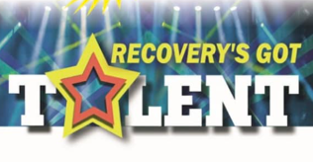

This year, Recovery’s Got Talent celebrated its 8th birthday! Who would have guessed it would be still flourishing years on from those initial meetings in the Malthouse in 2018!!

This year certainly didn't disappoint - 7 brave and talented acts performing on the big stage, plus a range of non-competing performers in the second half. Two fabulous co-comperes who bounced off each other’s energy, a panel of awesome judges which included the Mayor of Bury St Edmunds and last year’s winner and a mega raffle presided over by Jon Wright from BBC Radio Suffolk. A dedicated and hard working team of no less than

19 awesome individuals, some of whom were part of this year’s steering group and all who gave up their Saturday to help on the day. The result - a heartfelt and uplifting celebration of recovery of which we are so proud. A big thank you to everyone who made this year’s event happen and came along to support the event.

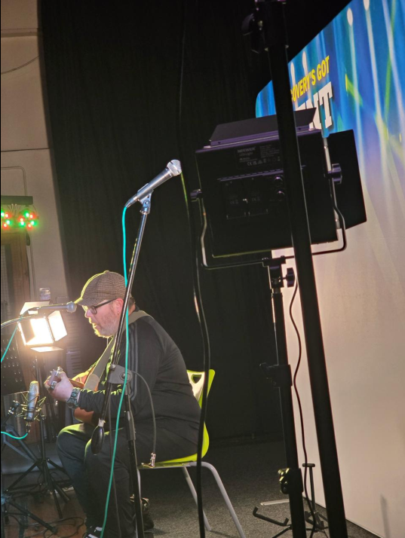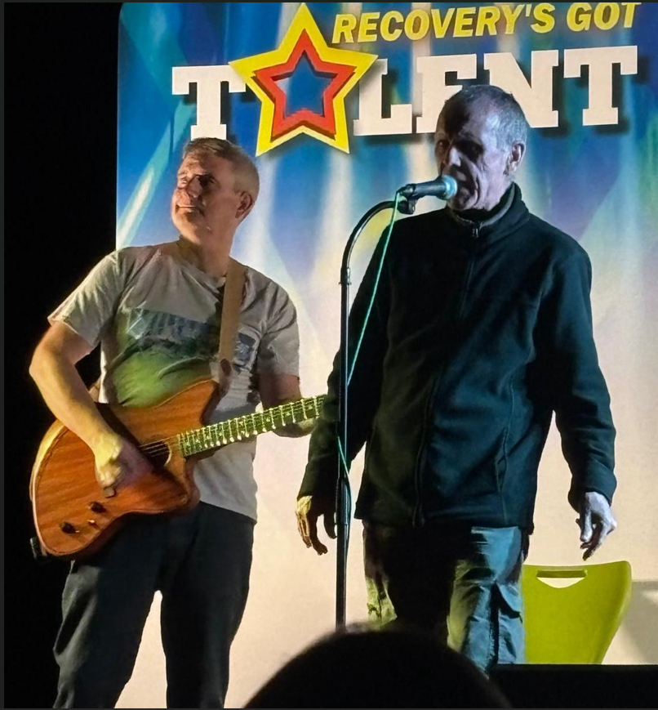

Recovery’s Got Talent 2026 will be on! Our raffle, donation and T shirt auction raised a grand total of £278.24. Every penny of which will go towards next year’s show. We will start preparing in January. Keep your eyes peeled for next year’s date!

FOUNDATIONS: young people and families affected by someones drug and / or alcohol use

Foundations is the team in the Suffolk Drug and Alcohol Service that offers young people young adults and families the support they need to cope with someone else’s drug or alcohol use or because they are using drugs or alcohol themselves and need to know more, make changes or stop.

The team are outreach, covering the whole of Suffolk and will see a client where they are.

We want to be able to work alongside other support services to compliment the interventions

already taking place and we are happy to consult
on cases to look at the best way forward for the young person.

To discuss further please email ruth.lee@turning-point.co.uk or john.weller@turning-point.co.uk

WELCOME TO CLASS OF AUGUST 2025

August was a very busy month. We had a class of 13 new team members going through our induction programme.

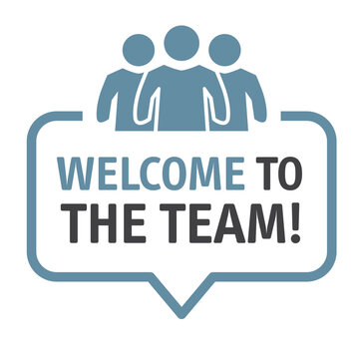

We have experienced lots of recruitment challenges over the last 4 years and as we moved into 2025, we had vacancies in most of our teams. We collated the feedback from the leavers and the reasons that led to their departure.

We put together a 3 staged approach to our recruitment process. Recruitment events were held across all 3 localities. This provided an opportunity for potential candidates to come and
see us and learn about the aspects of the recovery worker role including the good, the bad and the ugly! We also introduced assessment centres to help candidates meet more people and have a better understanding of how we work. These consisted of a professional interview panel, a lived experience panel, a practical exercise as
well as another opportunity to hear about the role to ensure the expectations were understood.

Following appointments, 13 new recruits joined the Class of August 2025. The new approach to
our induction includes spending 3 weeks classroom learning and 1 week shadowing to
ensure people have protected time to learn and understand the service and their role.

Each new intake helps us to further enhance the induction process to make it even better for the next cohort. During the month of October, we inducted a further 6 new starters across the county and look forward to further developing our new approach to recruitment and inductions.

IPSWICH GRADUATES

The graduation was attended by people who have completed their psychosocial interventions with the partnership and are closed to leaving treatment. It took place at Iceni and was an emotional afternoon with the people we support and their families telling us what a difference the interventions made, and how happy they are to see real change in their loved ones.

Some of the graduates are waiting to complete their training to become a peer mentor to support others starting their treatment journey. We look forward to welcoming them to our team.
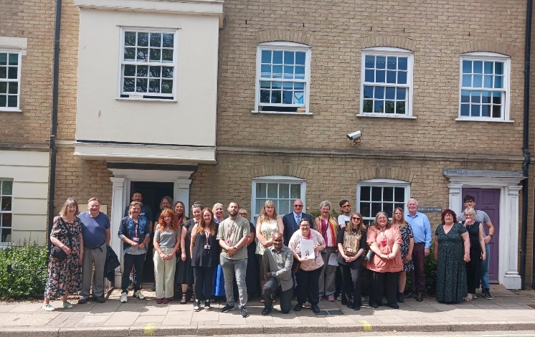

INTERNATIONAL OVERDOSE AWARENESS DAY: 31ST AUGUST 2025

To mark the International Overdose Awareness Day a stand was set up within the Ipswich hub so the people we support, and all our visitors could see it. Discussions and advice were given surrounding the use of naloxone along with other harm minimisation advice. Purple ribbons and bracelets were given out to remind everyone how important it is to be overdose aware.

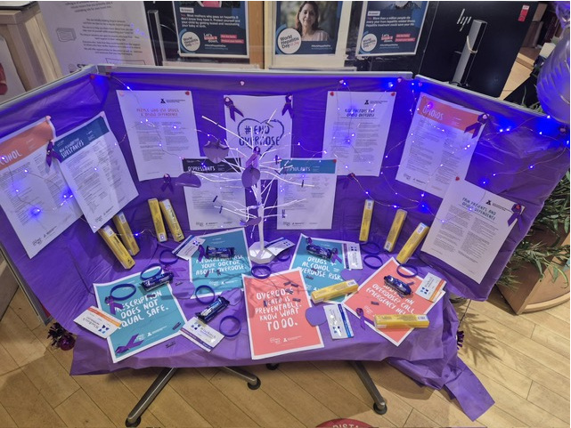

ANGLIA CARE TRUST’S OUTREACH TEAM

As part of our Anglia Care Trust’s partnership with Turning Point and Iceni, the Drug and Alcohol Recovery Outreach team had training with Steve Wood, Harm Reduction Lead, from Turning Point
around offering service users harm reduction advice.

The team were each given backpacks with harm reduction kits and instructions to help service users before we support them into treatment services.

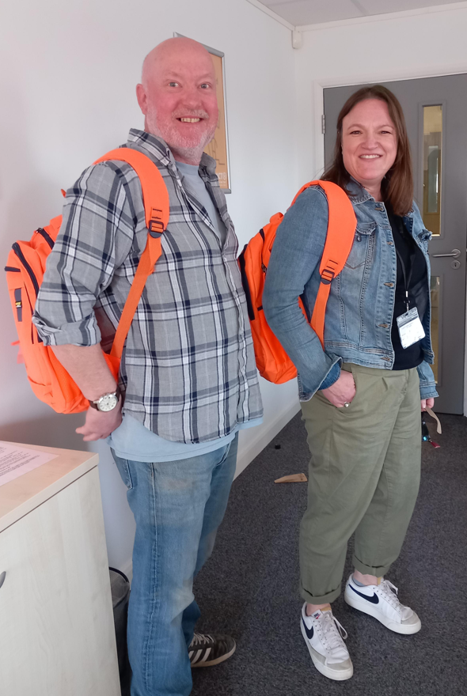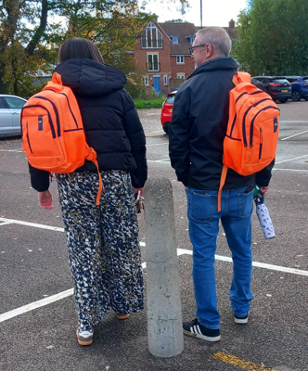
Above are Jason Connell and Anna Davis modelling their new backpacks

Above are Daisy Bailey and Brian Peters on outreach ready to support service users.

INDIVIDUAL PLACEMENT SUPPORT,
provided by:



The Individual Placement Support (IPS) Employment Team have been a part of the service for 18 months now, supporting clients to become ready for work, to find work to fit with preferences that is sustainable and providing all important in work support for the client and employer. The team is made up of three Employment Specialists Jess, Nareece and Paul with Chloe as the Team Leader.

3 clients have sustained employment for a whole year with 43 job starts since the service started.

The team have recently had their Fidelity review
(their equivalent of CQC) and scored 89, which is 10 points higher than the East of England Regional Average and the highest Fidelity score in Suffolk!

Clients are really positive about the service:
'She's got the determination, I couldn't thank her enough. Without her, my mental health would be so poor. She's supporting me at my own pace'

'It has been really nice meeting [ES], she is really lovely and supportive. Nice chatting to her. We get on really well. Feel like I can open up to her, her energy is just great'

If you want to get in touch please contact Chloe Janes - chloe.janes@turning-point.co.uk to discuss anything IPS related.

ICENI

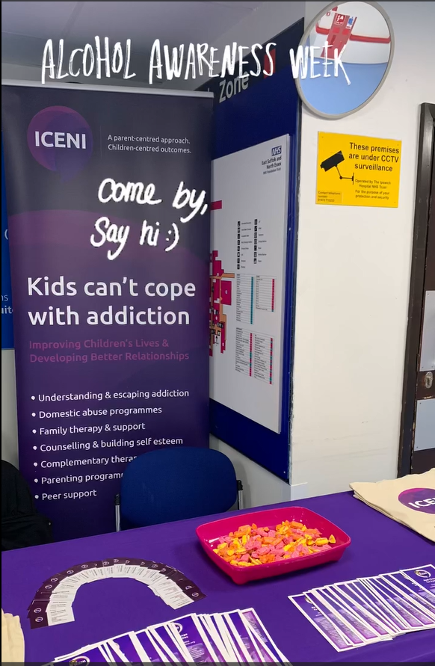

Iceni attended the hospital for alcohol awareness week alongside our colleagues at Turning Point and ACT.

Through this we were able to speak to professionals and the public about what we can provide as individual agencies but also collectively as a partnership.

TRAINING

We are lucky to have Michelle Cains join us as our new Team Leader: Training. Michelle has 15 years’ experience of working as a trainer and has been working through her induction to familiarise herself with the Suffolk Drug and Alcohol partnership and how we can work together to support the needs of our partner agencies.

To see our latest training offer please the TP Training News Ext Oct 2025 below.

PROFESSIONAL OPEN DAYS

We are excited to open our doors again across the county for Professionals Open Day, welcoming our partners in to explore our work, and connect with our team. This event is a great opportunity to network, learn about the drug and alcohol field and discover more about our service and what we offer. Please do join us for a for an engaging day of collaboration and conversation.

Our events are:
BURY ST EDMUNDS
11am to 2pm, Wednesday 18th February 2026
Woolhall House, Woolhall Street, Bury St Edmunds, IP33 1LA

IPSWICH
10am to 12.30pm, Thursday 19th February 2026
Sanderson House, 17-19 Museum Street, Ipswich, IP1 1HE
LOWESTOFT
11am to 2pm, Wednesday 4th February 2026
Woodbury House, Mill Road, Lowestoft, NR33 0PP

OUR CHRISTMAS HUB OPENING HOURS ARE:

Hub | Monday 22/12/25 | Tuesday 23/12/25 | Wed. 24/12/25 | Thursday 25/12/25 | Friday 26/12/25 | Saturday 27/12/25 | Sunday 28/12/25
Bury | 10am – 4pm | 10am – 4pm | 10am – 1pm | Closed | Closed | Closed | Closed
Ipswich | 10am – 4pm | 10am – 4pm | 10am – 4pm | Closed | Closed | Closed | Closed
Low-estoft | 10am – 4pm | 10am – 1pm | 10am – 4pm | Closed | Closed | Closed | Closed

Hub | Monday 29/12/25 | Tuesday 30/12/25 | Wed. 31/12/25 | Thursday 01/01/26 | Friday 02/01/26 | Saturday 03/01/26 | Sunday 04/01/26
Bury | 10am – 4pm | 10am – 4pm | 10am – 1pm | Closed | 10am – 4pm | Closed | Closed
Ipswich | 10am – 4pm | 10am – 4pm | 10am – 4pm | Closed | 10am – 4pm | Closed | Closed
Low-estoft | 10am – 4pm | 10am – 1pm | 10am – 4pm | Closed | 10am – 4pm | Closed | Closed

PARTNERSHIP CONTACT DETAILS

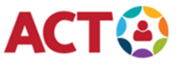 | 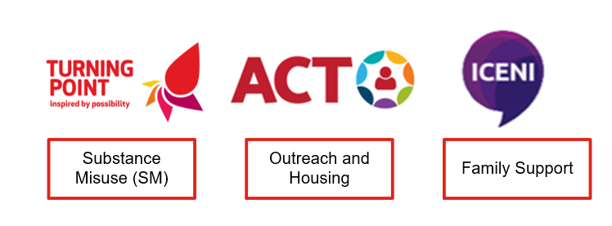
Referrals for substance use support: | Web: For Professionals | Turning Point (turning-point.co.uk)
Referrals for family and friends affected by a loved one’s substance use: | Email: ECHUB.turningpointsuffolk@nhs.net  Phone: 07483 420567

If you require any support booking any of our training please contact Suffolklearning@turning-point.co.uk

To unsubscribe from this mailing list please email Bev.Jay@turning-point.co.uk and ask to be removed.

