Learning and Development
Newsletter – October 2025

Turning Point is dedicated to supporting continuous development for our partner agencies and other professionals working with people using drugs and alcohol in the Suffolk area. We are continuously adding workshops and resources to our training portfolio and encourage you and your teams to sign up to our informative sessions.
The training and workshops we provide are designed for those who would like to improve their awareness and understanding of substance use, the trends, harm reduction and the services we provide.
Please see below for available workshops.

These are all bookable via Eventbrite:

https://www.eventbrite.co.uk/o/turning-point-suffolk-drug-and-alcohol-service-94173390313

SUFFOLK DRUG AND ALCOHOL SERVICE

Drug Awareness

This workshop is an introduction to different types of controlled drugs, exploring some of the major issues connected to substance use. As well as providing an awareness of the possibilities for reducing drug related harm. It will focus on practical suggestions for those working with people who are using substances.

Dates:

February 17th 2026 | 1000-1400
April 21st 2026 | 1000-1400

The training will be a face-to-face workshop held at our Turning Point Bury Hub.
Address: 14 Woolhall Street, Bury St Edmunds, Suffolk, IP33 1LA.
Please book via Eventbrite (link above).

Alcohol Awareness

This workshop is an introduction to alcohol. It covers Harm Reduction, an overview of Turning Point alcohol pathways and a look at the Blue Light initiative, which provides alternative approaches for anyone who is at risk of alcohol related harm but who is not ready or is resistant to change and are unmotivated to engage with treatment services.

Dates:

January 23rd 2026 | 1000 - 1400
March 18th 2026 | 1000 - 1400
May 20th 2026 | 1000 - 1400

The training will be a face-to-face workshop held at our Turning Point Bury Hub 14 Woolhall Street Bury St Edmunds, Suffolk, IP33 1LA.
Please book via Eventbrite (link above).

Substance Workshop: Cannabis
(Virtual workshop on Teams)

This is an online workshop that aims to provide information on Cannabis, the effect it has on the body and the impact it has in the lives of our service users, as well as providing information on Cannabis specific harm reduction.

Date:
February 19th 2026 | 1100 - 1230

Substance Workshop: Ketamine
(Virtual workshop on Teams)

This is an online workshop that aims to provide information on Ketamine, the effect it has on the body and the impact it has in the lives of our service users, as well as providing information on Ketamine specific harm reduction.

Date:
March 20th 2026 | 1100 - 1230

Substance Workshop: Opiates
(Virtual workshop on Teams)

This is an online workshop that aims to provide information on Ketamine, the effect it has on the body and the impact it has in the lives of our service users, as well as providing information on Ketamine specific harm reduction.

Date:

April 23rd 2026 | 1000 – 1200

Chemsex Awareness
(Virtual workshop on Teams)
This workshop provides an introduction to Chemsex and its impacts. The workshop looks at the context and the culture around the use of drugs during sexual activity mostly between men who have sex with men (MSM). The workshop also explores the types of drugs used; the physical and psychological impact they can have on the people using them and how we can support them to reduce the harm.
Date:

January 15th 2026 | 1100-1300

Fetal Alcohol Spectrum Disorders - FASD
(Virtual workshop on Teams)

This workshop is an introduction to the impact of
alcohol use during pregnancy, which can result in mental and physical problems in the baby, called Foetal Alcohol Spectrum Disorder (FASD). This workshop is delivered by one of our clinicians who have a specialist interest.
.

Substance Use and Mental Health Training for Professionals (Elearning)
This free online learning has been designed by our experienced specialists for anyone to access, regardless of level of knowledge, to increase awareness and understanding of people who have a co-existing or a co-occurring mental health or substance use condition.
You can access this learning through our Turning Point website under For Professionals, you will need to register to access the elearning (Free).
SUFFOLK DRUG AND ALCOHOL SERVICE

Find Out More (Online Learning)

Turning Point provides online learning that provides individuals and professionals with informative advice and guidance around the following areas: www.turning-point.co.uk

Substances: Alcohol, ketamine, Benzodiazepines, GHB, Amphetamine’s, Cocaine, Cannabis and Ecstasy.

Wellbeing: 5 Ways to wellbeing, Low Mood, Healthy Eating, Physical activity, and Sleeping Difficulties.

Stress: Anxiety, Managing Worries and Stress at work.

Gambling

You can access any of these learning articles through Turning Points website under Resources and Advice.

Please see link below:

www.turning-point.co.uk/resources-and-advice
Date:

May 22nd 2026 | 1000 – 1200

Partnership contact details:

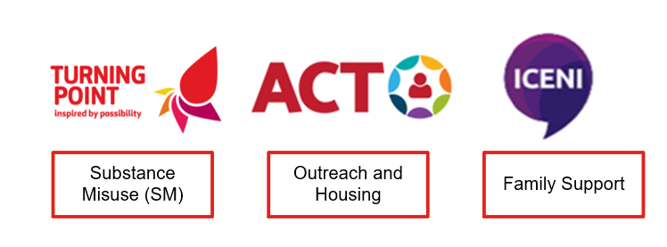 | Referrals for substance use support:  Web: For Professionals | Turning Point (turning-point.co.uk)  Phone: 0300 123 0872  Referrals for family and friends affected by a loved one’s substance use:  Email: ECHUB.turningpointsuffolk@nhs.net  Phone: 07483 420567
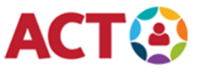 | Web: Anglia Care Trust | Multi service charity  Email: admin@angliacaretrust.org.uk
Web: Contact - Iceni (iceniipswich.org)
Email: admin@iceniipswich.org

If you require any support booking any of our training sessions or wish to discuss bespoke sessions, please contact SuffolkLearning@turning-point.co.uk

To unsubscribe from this mailing list please email Bev.Jay@turning-point.co.uk and ask to be removed.

