WELCOME!

Welcome to the second edition of our newsletter. We are delighted to reconnect with you and share the latest updates, insights, and opportunities across the substance use field.

We hope you find this newsletter helpful. It is our way of keeping you informed, inspired, and supported as we work together for the people we support.

MEET OUR FAMILIES WORKER – meet Jules

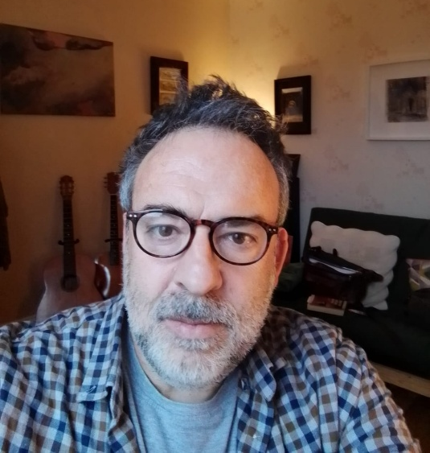

Further to the appointment of our new Families Worker, Jules, I am delighted to announce three new 5-Step Groups started in January. These groups are in Ipswich, Bury St Edmunds, and Lowestoft and will give those affected by a family member’s substance use the opportunity to meet on a fortnightly basis.

The groups are already at near maximum capacity and will offer those attending the chance to share their experiences with others in situations similar to their own and learn how to navigate the emotional and social challenges they face with hope and resilience.

The plan is that these groups might develop into peer-led support groups in the future with the 5-Step Groups continuing to run on a twelve-week cycle. Connection is such a vital part of the recovery journey, and it is equally as important for those affected by others’ use so these groups are an essential part of our service.

Alongside these groups aimed at adults, the Foundations Team continues to support those who are 21 and under on a one-to-one basis using the Steps To Cope method.

To refer families affected by a loved one’s substance use please use the below link:
Get Support with Substance Use from Turning Point | Turning Point
Or email
foundations@turning-point.co.uk

NALOXONE – Click and Deliver

Naloxone is now advertised on our website. Anyone that has a concern regarding people who use illicit drugs and are at risk of overdose, can now order Naloxone from Turning Point free of charge and this will be delivered to your address.

The process is quick and simple, we will show you how to use it, when it should be used and how to dispose of it.

By clicking on our Naloxone Click and Deliver service, you could be saving a life.

Naloxone Click and Deliver | Turning Point

NEW YEAR, NEW START

This January, Clive, one of our Peer Support Workers, and three of our volunteer Peer Mentors helped to run an Alcohol Awareness stall for staff and patients at Ipswich Hospital. They were joined by our partners from Iceni and ACT to provide a partnership presence and promote the Suffolk Drug and Alcohol Service.

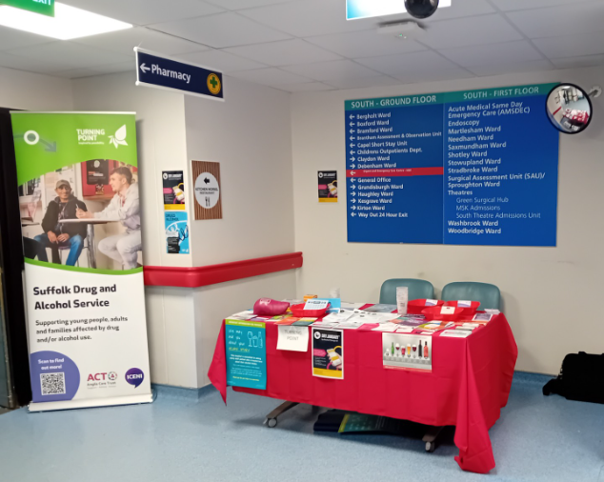 | 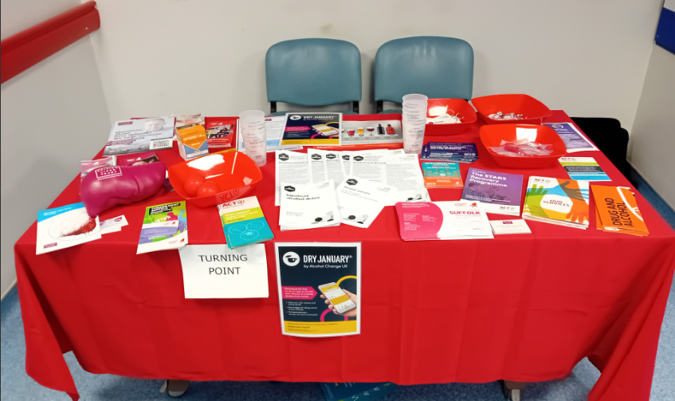

In other news, Mollie, our Advanced Recovery Practitioner, did an alcohol awareness quiz with our volunteer Peer Mentors in the Bury Hub to raise everyone’s knowledge about alcohol.

SUCCESS STORY

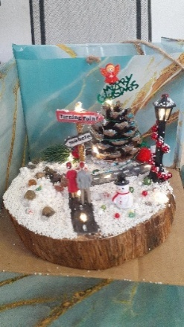 | My client has been refocusing their energy back into creativity and resin art, and away from illicit substances. They have been attending arts fairs and been able to sell some of their work.

This was not only helpful financially before Christmas, but it has also allowed them to reignite their creativity, and as part of their care plan refocus and distract away from substance use.

To show their gratitude for the help Turning Point provided, they made a Christmas scene resin art for their recovery worker to display at the Ipswich hub. The scene depicts a festive journey of recovery, and two clients standing at a fork in the road, one path is a rocky road (quite literally) signposted "Nowhere", the other signposted "Turning Point".

PSYCHOLOGY PLACEMENTS – meet one of our student placements and find out about her placement

While completing my Masters in Applications of Psychology at the University of Suffolk I underwent a placement with Turning Point for several months. Here I worked closely with the criminal justice team where I was able to experience what it is like to work from locations such as the Turning Point hub, the courts, and the Police Investigation Centre (PIC). I got to delve into my interest in addiction. I worked first hand with clients experiencing drug and alcohol related addictions. I was able to shadow recovery workers completing one-to-ones with clients, as well as sit in on groups and see how these work. I really enjoyed my time at Turning Point.



Upon finishing University I began working at Anglia Care Trust, where I have now been for a year. My role at Anglia Care Trust involves working very closely with Turning Point. I support clients with assessments, referrals and appointments as well as offering support for any additional struggles they experience that may make their recovery journey particularly difficult. I help clients with engagement and speak with them regularly to ensure we are meeting their

needs as best we can. I really enjoy my role, it is very rewarding, and it is very nice for me to have the familiarity of Turning Point from my placement.

ROMANIAN DAY

Paula and Sallieanne, from the Ipswich hub, attended the Ipswich Romanian Community ‘Romania Day’ on December 1st.

It was a joyful event with Romanian food, singing and dancing and was well attended by professionals and members of the ‘Ipswich Romanian Family’.

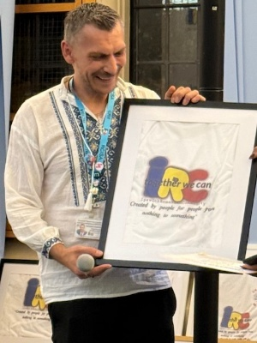

CRUMPETS & CONVERSATIONS

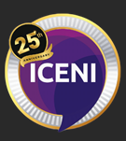 | Introducing Crumpets & Conversations, a relaxed, informal space for local organisations and the queer community to come together, share experiences, and
inspire each other to create change – all over a hot cuppa and a plate of crumpets.

Our next Crumpets & Conversation event is on 19th March 16:00 - 18:00 at Iceni. March’s topic for discussion will be the broad topic of ‘Mother’.

Mother as an advocate, as a nurturer, as a praise singer. What is it to be a mother in the LGBTQ community?

What are peoples experience of mothers when they have come out to their family, and how have Chosen Mothers stepped up to be the maternal
and what we offer. Please do join us for a for an engaging day of collaboration and conversation.

PROFESSIONAL OPEN DAYS

We are excited to open our doors again across the county for Professionals Open Day, welcoming our partners in to explore our work, and connect with our team. This event is a great opportunity to network, learn about the drug and alcohol field and discover more about our service

Lowestoft held their Professionals Open Day on Wednesday 4th February. It was a great day celebrating and sharing the excellent work by the Lowestoft team, building on existing relationships as well as making new professional friends.

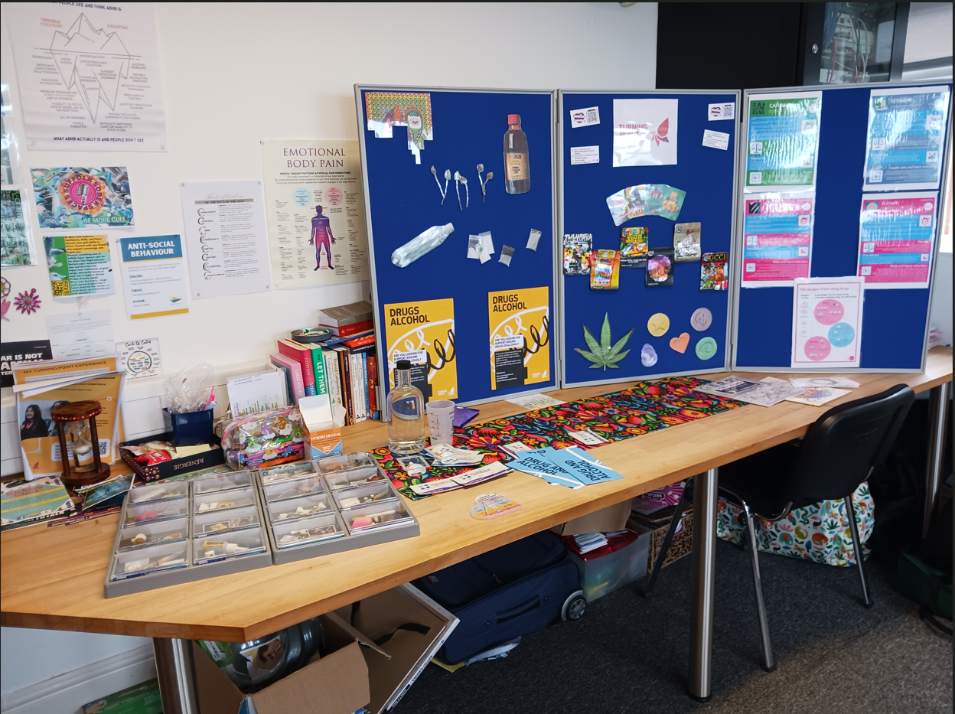

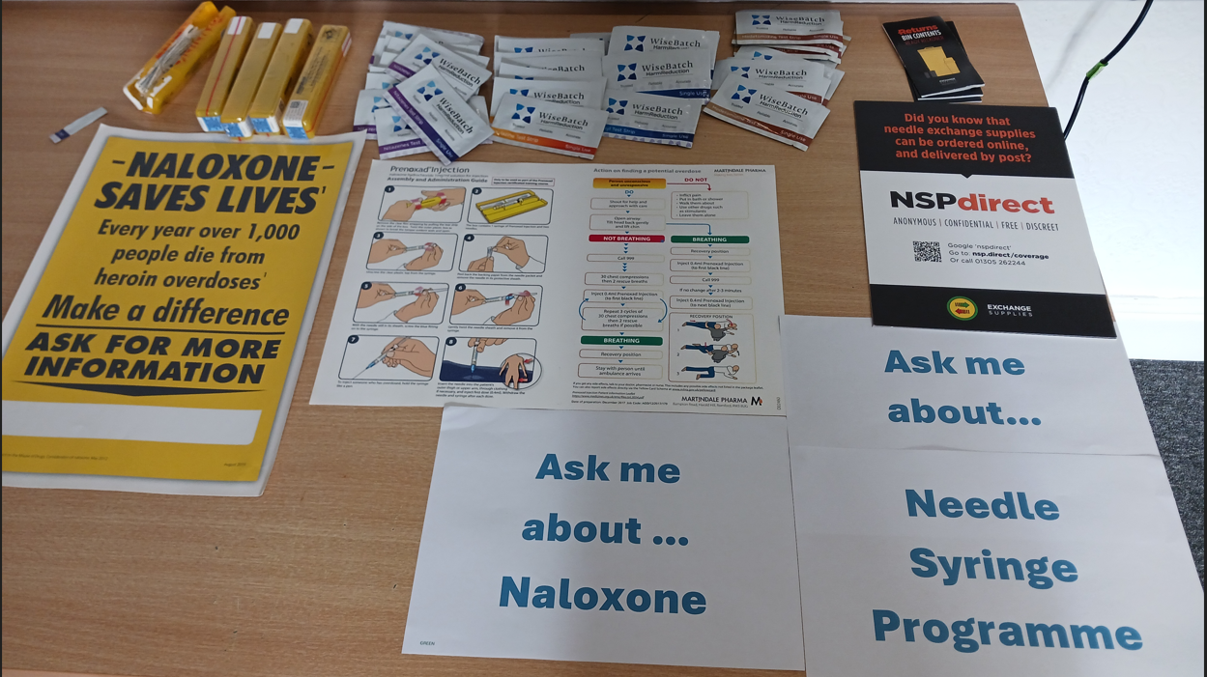

Upcoming Professional day events are:

BURY ST EDMUNDS
11am to 2pm, Wednesday 18th February 2026
Woolhall House, Woolhall Street, Bury St Edmunds, IP33 1LA

IPSWICH
10am to 12.30pm, Thursday 19th February 2026
Sanderson House, 17-19 Museum Street, Ipswich, IP1 1HE

We hope to see you soon.

TRAINING

Our courses are currently planned until October 2026. To find out more see the TP Training News Ext Oct 2025 below.

Or use our QR code to access our courses via Eventbrite.



CO-OCCURRING CONDITIONS ROADSHOWS 2026
One life, not two labels

The Suffolk Systemwide Mental Health and Drugs and Alcohol Working Group is a multiagency group focusing on improving the resources and support for people who experience poor mental health and substance use. As part of this group, there is a training workstream and the 2026 roadshow.

Turning Point, Suffolk Mind, Norfolk and Suffolk NHS Foundation Trust and Suffolk County Council are really excited to showcase the support available within Suffolk and provide a great opportunity for networking, sharing ideas and providing feedback. There are two events;

East and West Suffolk
9.30am – 3.30pm, Venue 16, Tuddenham Road, Ipswich, IP4 3QJ

Waveney
9.30am – 3.30pm, The Victoria Hotel, Lowestoft, NR33 0BZ

For more information and to book your place online: www.eventbrite.co.uk/o/turning-point-suffolk-drugs-and-acohol-service-94173390313 or scan the QR code



ANGLIA CARE TRUST
Recovery Coffee is a group initiative developed by ACT Service User Engagement in collaboration with DAROS (Drug & Alcohol Recovery Outreach Service) and the Recovery Focused Accommodation. The programme was created in direct response to feedback from individuals who identified a need for safe, inclusive environments where they could rebuild their social circles while maintaining their sobriety, without sobriety itself being the central focus of the group.

Recovery Coffee provides an opportunity for service users to come together in a supportive, non-judgemental setting to form meaningful connections with others who share similar values. The groups offer a space to talk openly about a wide range of topics, share interests and hobbies, and develop friendships that promote confidence, wellbeing, and social inclusion. Currently, Recovery Coffee groups are established in Ipswich and Lowestoft.

For 2026 we are exploring opportunities to expand the range of activities to enhance engagement, promote holistic wellbeing, and ensure the groups continue to meet the needs of our service users. Recovery Coffee plays a vital role in supporting individuals to build fulfilling, balanced lives within their communities.

For eligibility service users must be supported by the DAROS & the Recovery Focused Accommodation Service.

The clients meet up and wellbeing walk (fortnightly)  Tuesday 10th March 2026 12pm – 2pm  Meet up at Café Nero, Ipswich incorporated the session around Christchurch Park | The clients meet up (fortnightly)  Sam’s Café, Lowestoft  Wednesday 18th March 26 10am – 12.00pm

PARTNERSHIP CONTACT DETAILS

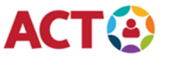 | 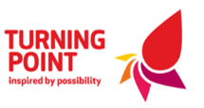 | 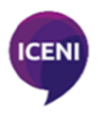
Referrals for substance use: | Web: For Professionals | Turning Point (turning-point.co.uk)
Referrals for family and friends affected by substance use: | Web: Get Support with Substance Use from Turning Point | Turning Point  Email: foundations@turning-point.co.uk

If you require any support booking any of our training please contact Suffolklearning@turning-point.co.uk

To unsubscribe from this mailing list please email Bev.Jay@turning-point.co.uk and ask to be removed.

