WELCOME…

to our third newsletter. The team have been getting out and about across the county and we are keen to share with you what we have been up to. These events are a great opportunity for us to promote the work we do as well as making new professional connections.

Please don’t forget to refer anyone who needs support due to their drug and / or alcohol use and anyone who is affected by a loved one’s drug and / or alcohol use. Referral information is at the end of this newsletter.

CO-OCCURRING CONDITIONS ROADSHOWS 2026

Turning Point’s Suffolk Drug and Alcohol Service has been planning to host two events across Suffolk in the early part of 2026. Both events, one in Waveney and one in Ipswich, are aimed at bringing together services who support people with the co-occurring conditions of substance use and mental health challenges. These events were initially planned for March however, due to unforeseen circumstances regarding the workshops, we had to move the dates of these events. The new dates are:

- Waveney: 09.30 – 15.30, 2nd July 2026
- East & West Suffolk: 09.30 – 15.30, 15th September 2026

These events will be a chance to reflect on progress made in developing interagency collaboration, to hear from speakers with lived experience as well as the services involved. You will also be able to have your say about our next steps for integrating the government’s Co-occurring Mental Health and Substance Use Delivery Framework into Suffolk.

We will also have music from ‘Music Prescription’ a local project that supports people to develop their musical talents as part of their ongoing recovery.

For more details about the events and how to book, please refer to the poster below.

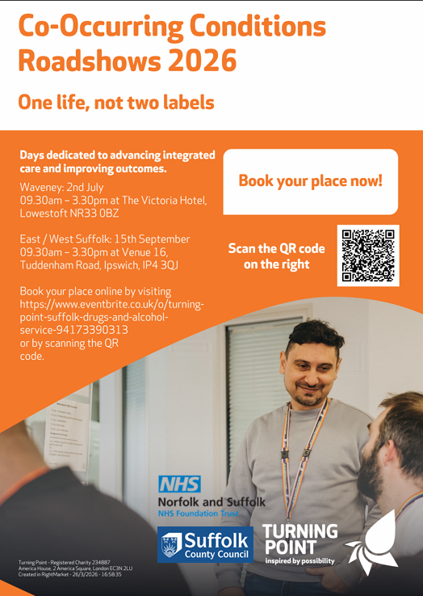

THE BIG PLASTIC COUNT

 | Steph, our Recovery Communities and Co-Production Team Manager
and Sallieanne, Ipswich Team Manager took part in the Big Plastic Count which ran from 9th to 15th March 2026. It is an annual initiative where discarded plastic packaging is counted over a week. The type of plastic waste is recorded online,

and types of waste and recycling practices are analysed.

Steph was pleased to have taken part and commented “what surprised me most was how little of the plastic I used is actually being recycled” and Sallieanne had some assistance with her counting!

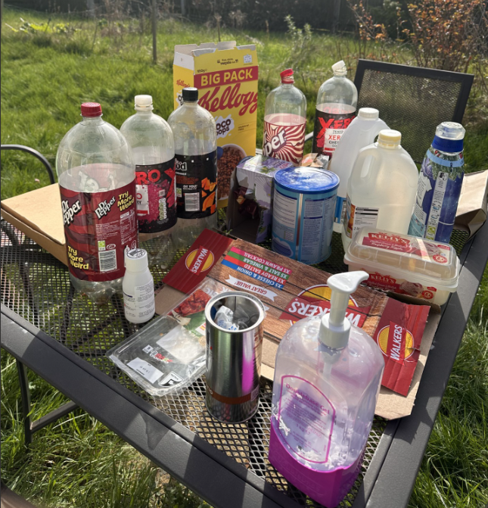 | 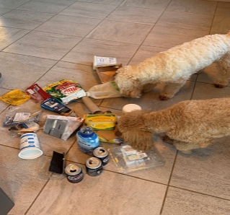

In return for taking part, participants receive a response which details your plastic profile.

MOOD MANAGEMENT

Mood Management was set up and has been delivered since 2022 in Ipswich and Bury St Edmunds. This has been supported by several Clinical Psychologist Trainees and, in the past two years, headed up by Lisa, our Psychosocial Interventions Lead in Ipswich. Over the past six months we have been collecting client feedback to improve the delivery, including the development of workbooks and group room images to explore next steps for Mood Management.
We invited past group members to join a focus group. Based on this, we began delivering The Compassionate Mind group in January 2026. We have now completed the first cohort of this group, who graduated in March 2026. Whilst it is still early days, we have received positive feedback from the graduates. We plan to deliver the next group in April and roll it out in Bury St Edmunds over the summer.

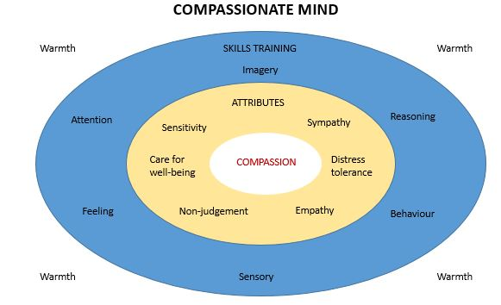

VISIT FROM SUFFOLK FIRE AND RESCUE SERVICE

Our Peer Mentors have been liaising with Suffolk Fire and Rescue Service to build awareness of the preventative work they offer. In January, our Ipswich Peer Led Engagement Group hosted a member of the Suffolk Fire and Rescue team to run an awareness session for attendees on fire safety and how to access fire prevention advice.

Suffolk Fire and Rescue also did a presentation at our Ipswich supervision group in February. Our Peer Mentors found this informative and came away with lots of useful tips on how they can
access support for those at increased risk fire safety wise.

We are planning to continue working with the service to raise awareness in Bury St Edmunds and Lowestoft going forward.

JOB CENTRE + HEALTH AND WELLBEING EVENT

In February, we joined the Health and Wellbeing Event at the Jobcentre. It was a great chance to meet local people and connect with other services across Suffolk. We were also pleased to be visited by the Suffolk High Sheriff, who stopped by to hear about our work.

UNIVERSITY OF SUFFOLK JOB FAIR

Our Ipswich Hub team recently attended the Job Fair at the University of Suffolk, with Zoe, Emma and Reece, our Peer Mentor, representing the service.

The event was a great opportunity to engage with students, resulting in several promising CVs and strong interest in our work.
It was also encouraging to hear members of the community express their gratitude for the support and impact of our service.

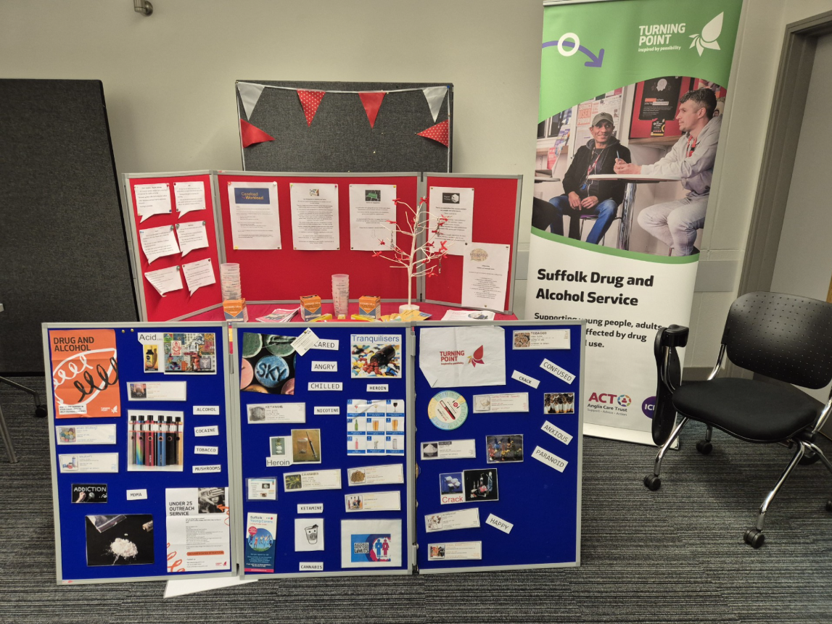

WELL MINDS EVENT IN LOWESTOFT

On 20th January 2026 Anna, Team Manager and Chris, Team Leader from the Lowestoft service represented Turning Point at the Well Minds event at Water Lane Leisure Centre.

This year, the event was even bigger and better with representation from diverse organisations including Norfolk and Waveney Talking Therapies, local gyms and fitness services, a Menopause Specialist, and our partner service Anglia Care Trust!

There was a super turn out from members of the public of all ages and the networking among colleagues was also great.

At the Well Minds event in February Anna presented a workshop on trends in substance use in the town and the various options for treatment from Turning Point.

Anna also ran a second workshop in the afternoon on Motivational Interviewing, specifically
Developing Discrepancy. The participants were enthusiastic and supported each other in small groups to address all sorts of issues from
ambivalence about getting active to chocolate consumption!

PROFESSIONAL OPEN DAYS

Our next Professionals Open day is in Ipswich. You are all more than welcome to come along, meet the team and find out more about what goes on in a drug and alcohol service.

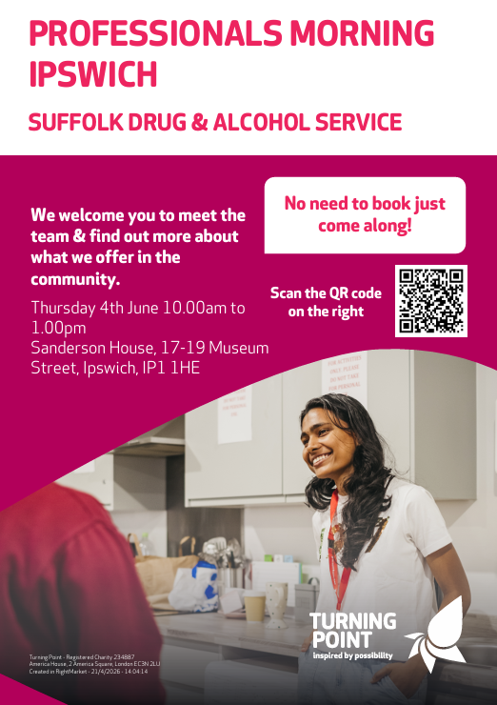

KETAMINE

Across the country we have seen a change in the drug scene and it’s worrying.

There has been a dramatic rise, in Suffolk 261%
since 2022, in young people using ketamine. It is a dissociative anaesthetic used in emergency medicine but has also been used as an illicit drug for many years mainly in the illegal party scene.
We are now seeing people using large quantities alone and daily. These people are ending up with serious health issues including bladder and kidney damage, low body weight and serious physical pain.

Turning Point have a dedicated ketamine pathway to support anyone who is using ketamine and wants support to make changes.

If you know someone who is using ketamine please make a referral as soon as possible. Early support means the impact of ketamine will be lessened and less likely to be permanent.

Things to look out for in those who are using in a problematic way:

- Frequent or urgent urination, sometimes with accidents
- Complaining of pain when urinating
- Losing weight or not eating properly
- Spasms or stomach cramps, known as K-cramps
- Constant tiredness or lack of energy
- Ongoing nosebleeds or scabs from snorting the drug
- Not remembering chunks of time or forgetting things easily
- Withdrawal symptoms like shaking, excessive sweating, vivid dreams or nightmares

💚 Mental Health Awareness Week in Ipswich & Bury St Edmunds 💚
This week, at our Ipswich and Bury St Edmunds hubs, Martin and Zoe, our Mental Health Champions, have set up a dedicated stall inside the service to raise awareness of mental health and the support available.

The stall is a space to share information, start conversations, and encourage people to take action — whether that’s reaching out for support or simply learning more about mental health and wellbeing.

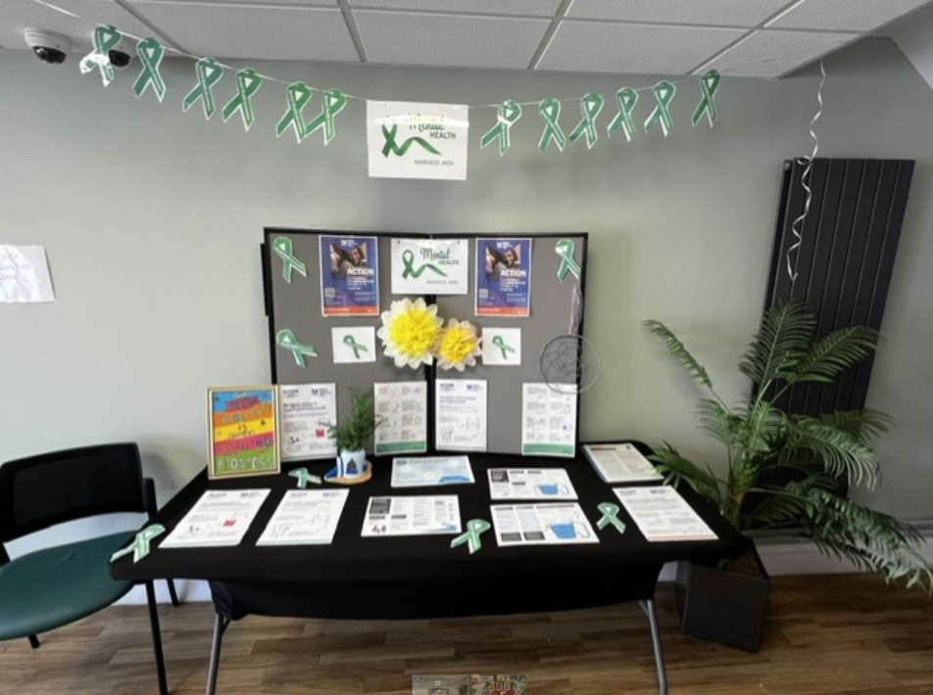

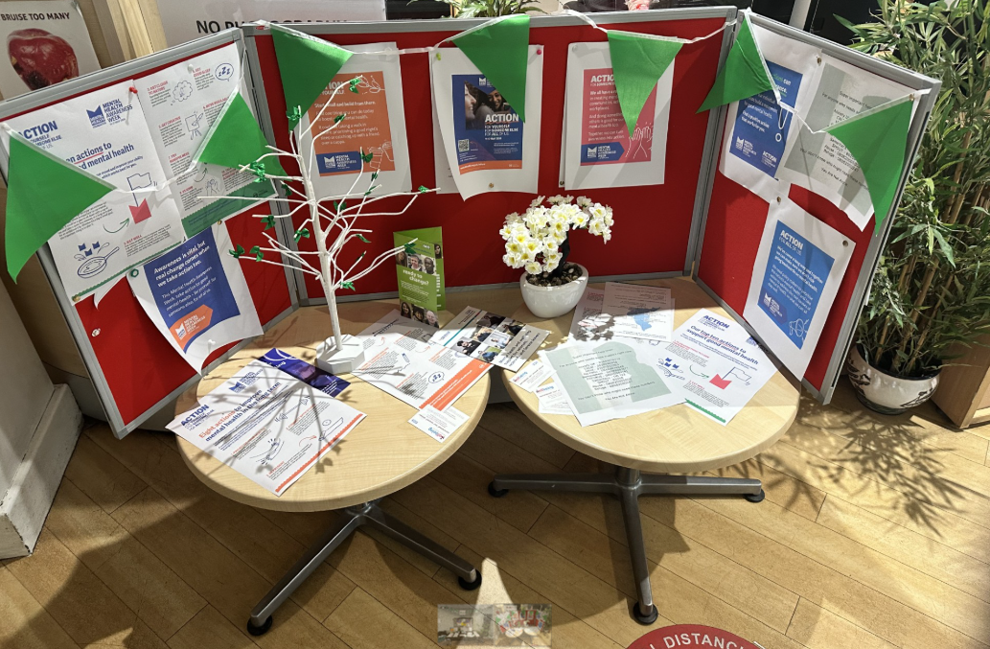

IMPACT EVENT

On 15th April 2026 Anna, Team Manager for Lowestoft, attended an Impact event which included many agencies such as Environmental Control, the Police, local councillors and even Parking Enforcement to reach out to the community around the town centre about any issues they might be having.

On our way we reported fly-tipped rubbish and Anna filled four bags of litter from the street! Fortunately it was good weatherwise and some good networking and learning about each other's work was done along the way.

TRAINING
Please use our QR code to access our courses via Eventbrite.



PARTNERSHIP CONTACT DETAILS

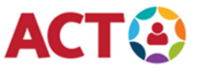 | 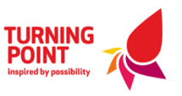 | 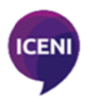
Referrals for substance use: | Web: For Professionals | Turning Point (turning-point.co.uk)
Referrals for family and friends affected by substance use: | Web: Get Support with Substance Use from Turning Point | Turning Point  Email: foundations@turning-point.co.uk

If you require any support booking any of our training please contact Suffolklearning@turning-point.co.uk

To unsubscribe from this mailing list please email Bev.Jay@turning-point.co.uk and ask to be removed.

