Bank Holiday Pharmacy Opening Times

Please note, Community Pharmacies are not usually required to open on Bank Holidays.
Please see our planned opening times below:

25th August 2025
(August Bank Holiday)

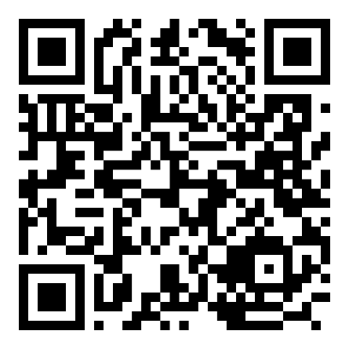
Please visit the NHS Website at www.nhs.uk and use the ‘Find a Pharmacy’ tool for alternative local Pharmacy opening times and to check for any updates on the availability of local pharmacies over the Bank Holiday weekend.
Or scan the QR code to take you directly to the webpage.

